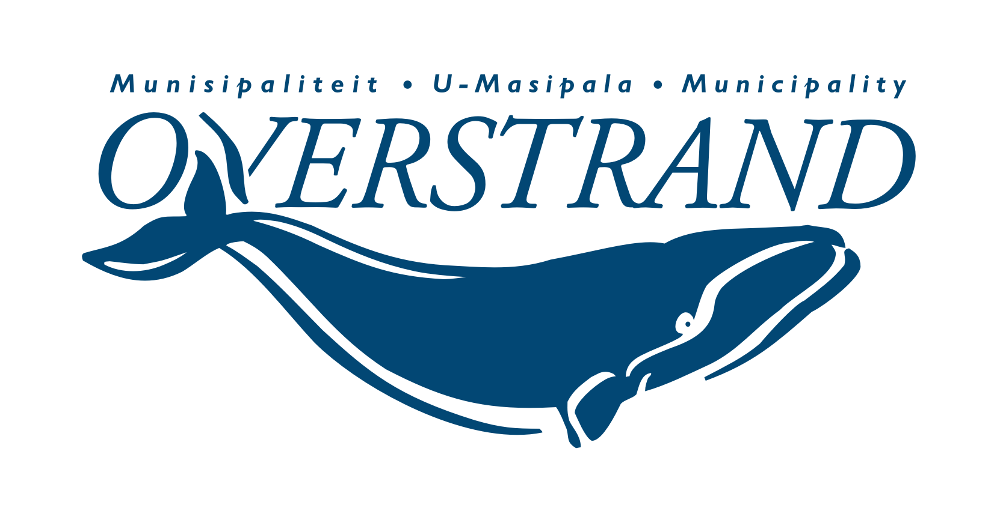
OVERSTRAND MUNICIPALITY
NON-GOVERNMENTAL ORGANISATIONS DATABASE REGISTRATION FORM
The purpose of this form is to give Non-governmental organisations in Overstrand the opportunity to have their organisation details listed on the municipality’s non-governmental organisations database. If you have any questions or would like assistance in completing the form, please contact Gerhard Smit at 028 313 8035

SECTION 1: DETAILS OF THE ORGANISATION
 | Name of the organisation:
 | Date established:
 | Date of last Annual General Meeting (AGM)
 | Objective of the organisation:
 | Main focus group/s of the organisations (example: youth, children etc.)
 | Physical Address:
 | Postal Code:
 | Postal Address:
 | Postal code:
 | In which Ward is the organisation?:
 | Wards in which the organisation renders a service (See page 3):
 | Contact Person: Name: | NAME |  |  |  | SURNAME
 | Position of contact person in organisation:
 | Cell:
 | Tel:
 | Email:

A | TYPE OF ORGANISATION (example Non-Profit Trust, Non-profit organisation etc.)
B | REGISTRATION STATUS |  |  |  |  |  |  |  | YES / NO
1 | Is your organisation registered?
2 | What is the organisation’s registration number?
C | REGISTRATION STATUS WITH SARS
1 | Is your organisation registered as a PBO?
2 | If your organisation is registered as a PBO, please enter your PBO number below:
3
D | PLEASE LIST SOME OF THE KEY ACTIVITIES / SERVICES OF THE ORGANISATION
E | PLEASE PROVIDE ANY OTHER INFORMATION ABOUT YOUR ORGANISATION THAT YOU FEEL WE SHOULD KNOW

THANK YOU FOR SUBMITTING AND REGISTERING YOUR INFORMATION
Please indicate in which Wards are the organisation active
WARD# | DESCRIPTION | Mark with X
1 | Stanford and Thembelihle
2 | Gansbaai North-East and Masakhane
3 | Hermanus, Voëlklip and a Portion of Westcliff (properties east of De Goede Street i.e Oncology Unit)
4 | Mount Pleasant, Hemel-en-Aarde Valley and a portion of Westcliff (properties West of De Goede Street i.e. Huis Lettie Theron)
5 | Zwelihle South
6 | Zwelihle North
7 | Sandbaai
8 | Hawston, Fisherhaven
9 | Kleinmond, Mountain View, Palmiet, Beverly Hills, and Extension 6
10 | Pringle Bay, Rooi-Els, Mooi-Uitsig, Betty’s Bay, Overhills, and Proteadorp
11 | Baardskeerdersbos, Eluxolweni, Pearly Beach, Buffeljagsbaai, Franskraal
12 | Zwelihle North-West
13 | Onrus and Vermont
14 | Blompark, De Kelders, Gansbaai South West, and Van Dyksbaai

